**NIMT - Document EB approval / SF**

**A) Strategic Framework Value**  
For this Development two rows are added in the Benefit Financial Indicator of->  
Strategic Framework Value LC (SFV LC)  
Strategic Framework Value CHF (SFV CHF)  
  
These two fields will be visible in the widget when Credit Type in Project Review and Evaluation will be selected as Strategic Framework project else not.  
  
**Credit Type** – Standard Project  
  
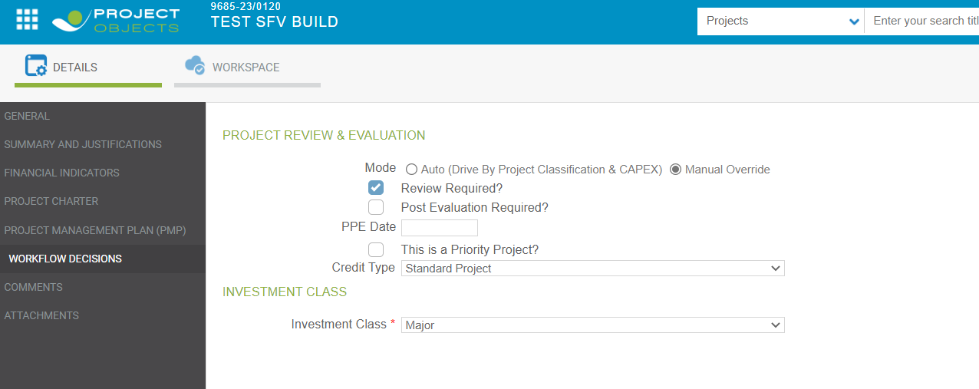  
  
  
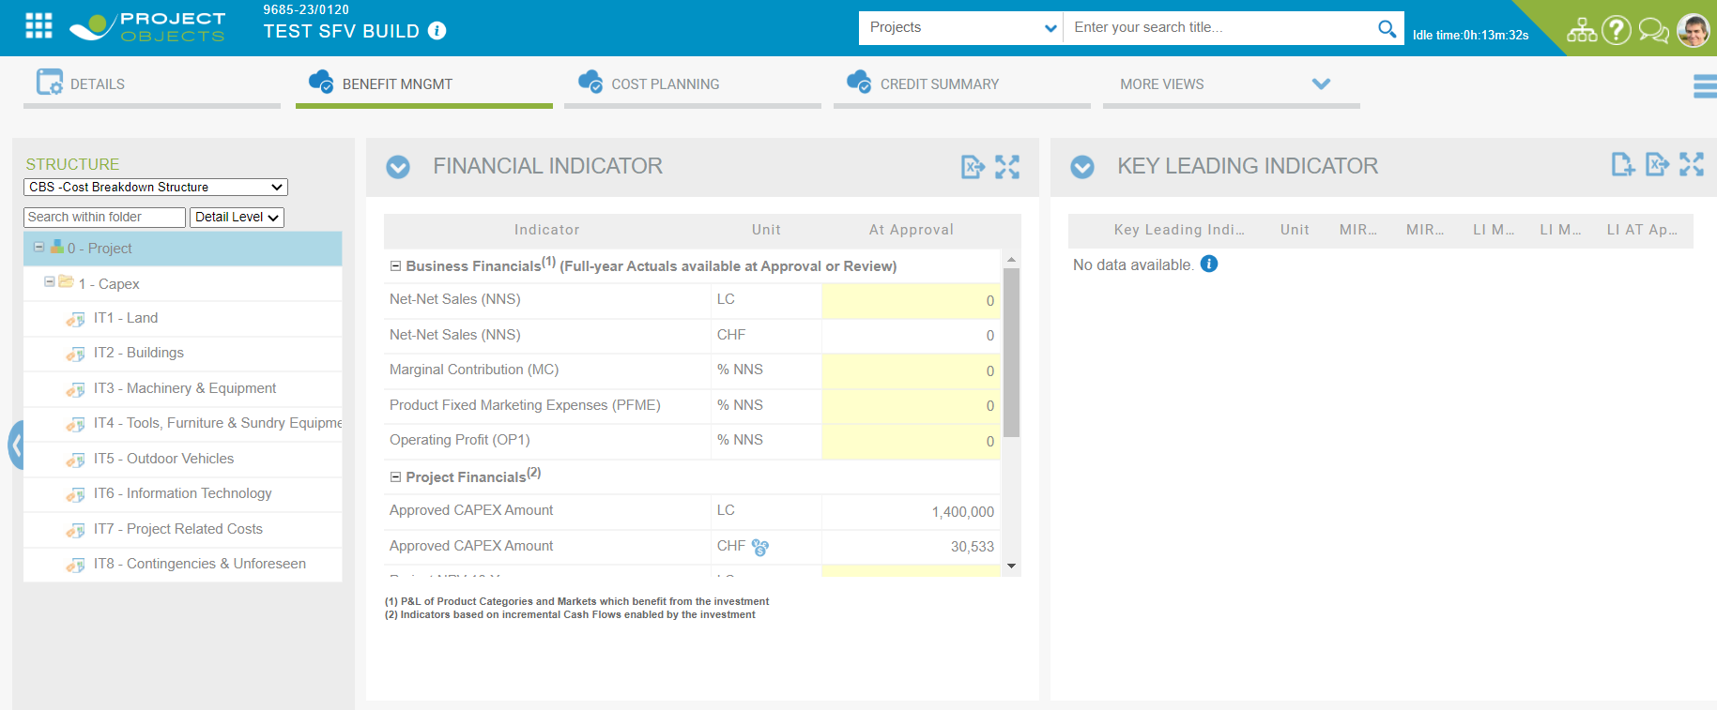  
  
  
  
  
  
  
  
  
  
**Credit Type** – Strategic Framework Project  
  
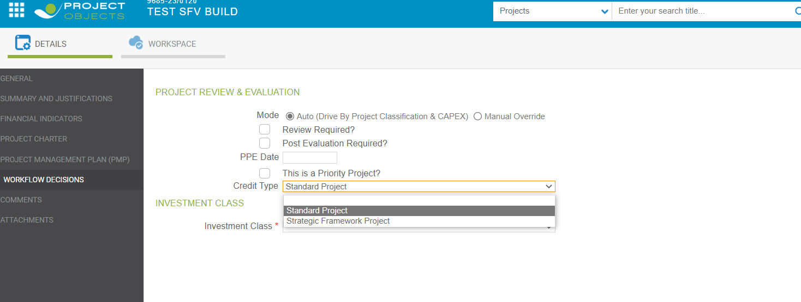  
  
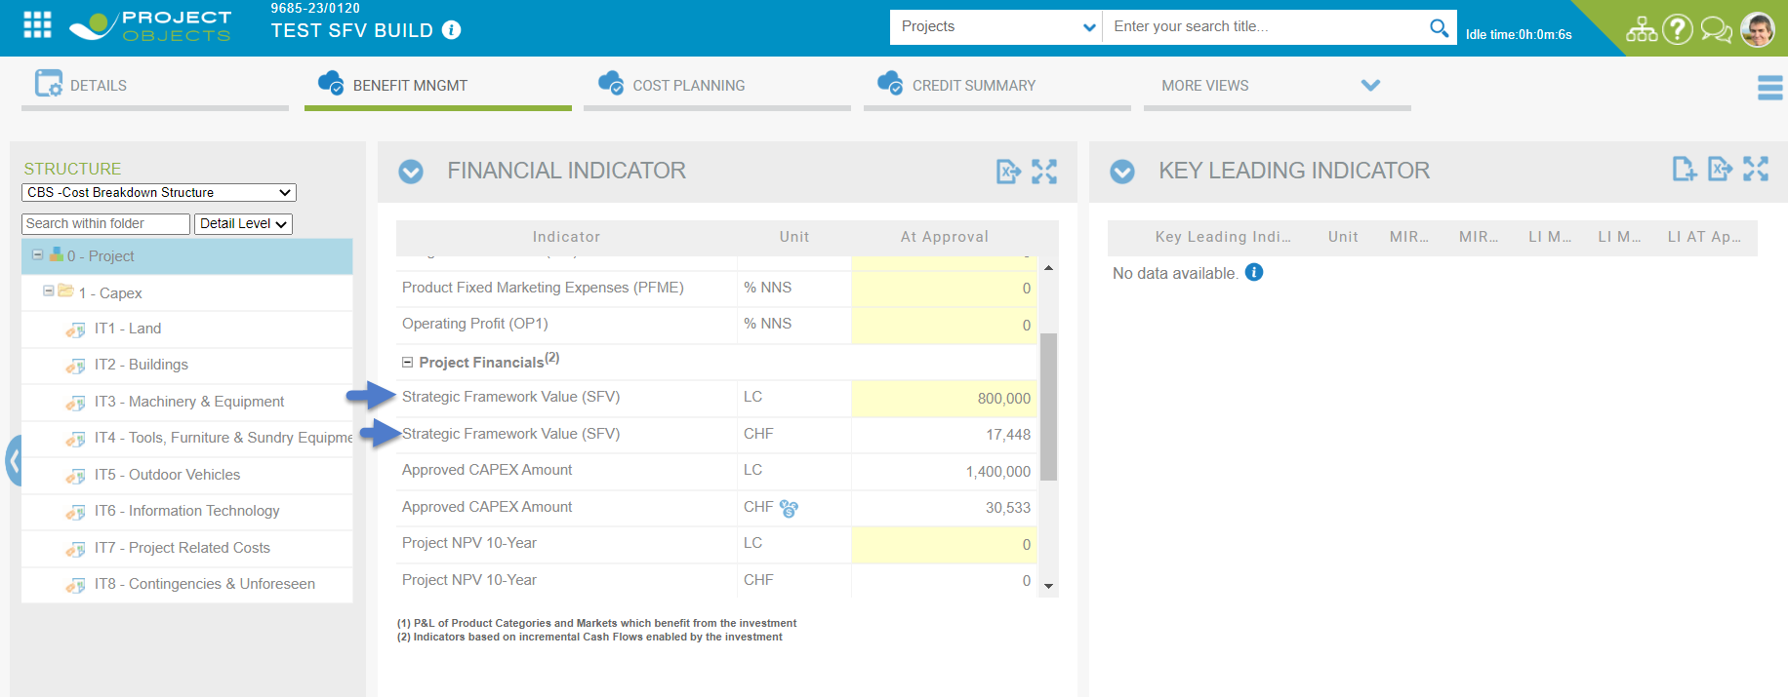  
  
SFV CHF value is calculated on the basis of Current Year Rate accordingly  
  
Permission needs to be granted for making the widget editable , then only we can edit the values.  
  
If Permission to “**Access as Global Administrator to be able to modify/overwrite Base Approval in the project widgets**” is ‘**OFF’** , then Widget will become disabled->  
  
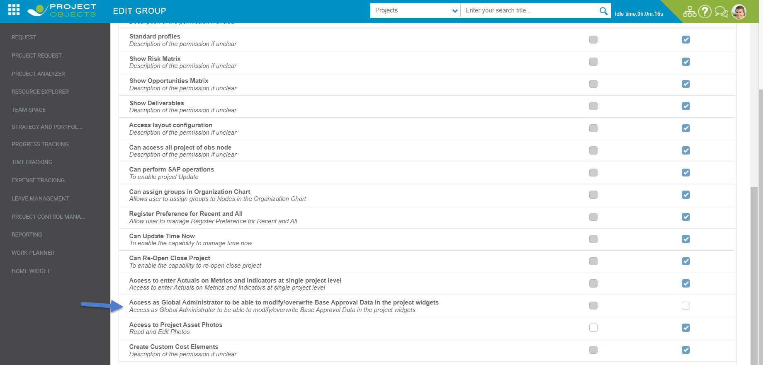  
**Disabled** Widget->  
  
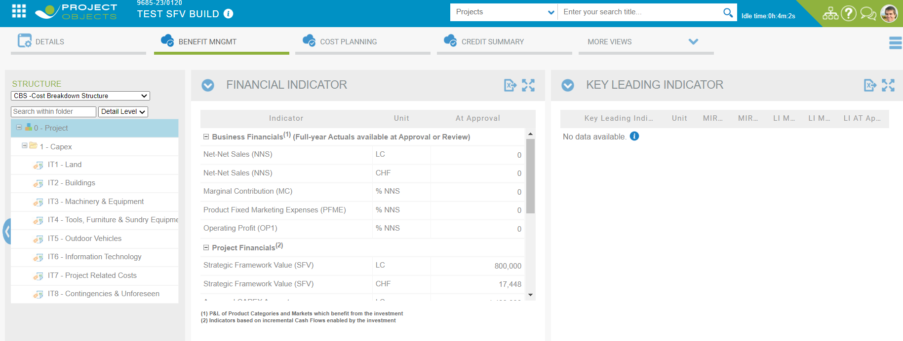  
  
If Permission to “**Access as Global Administrator to be able to modify/overwrite Base Approval in the project widgets**” is ‘**ON** , then Widget will be enabled to enter the values->  
  
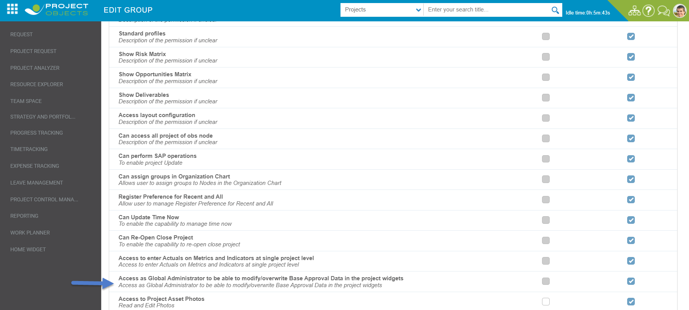  
  
**Enabled** Widget->  
  


When a new **Project Review Process (PRP)** is created the values of SFV LC and SFV CHF from **At Approval** column will be copied initially in the SFV LC and SFV CHF of **PRP** column   
  
New PRP created->  
  
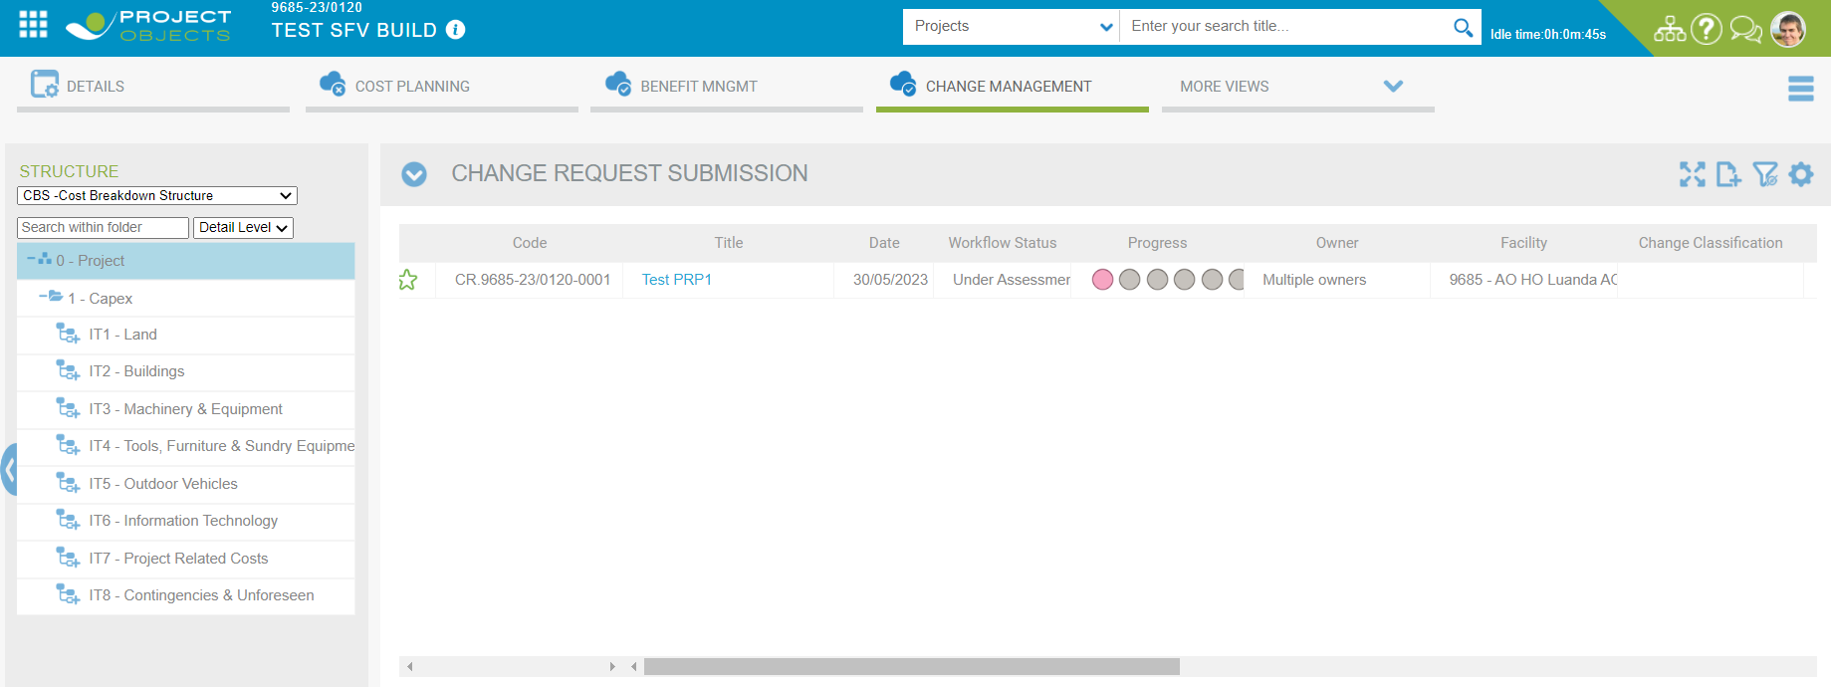

Values of SFV LC and SFV CHF from At Approval is copied ->

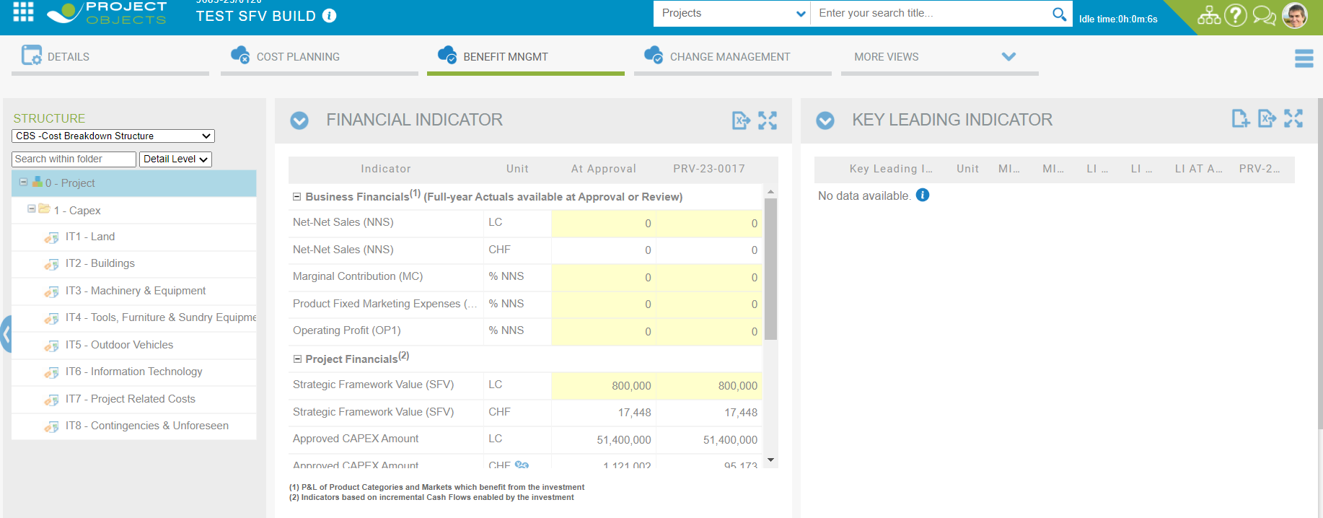

SFV CHF is also available for configuration in the workflow conditions. This value is mostly used in the step Zone/GMB CEO approval:

**B) Operations Summary**

Operations Summary control is there which needs to be configured in the Email Notification.  
  
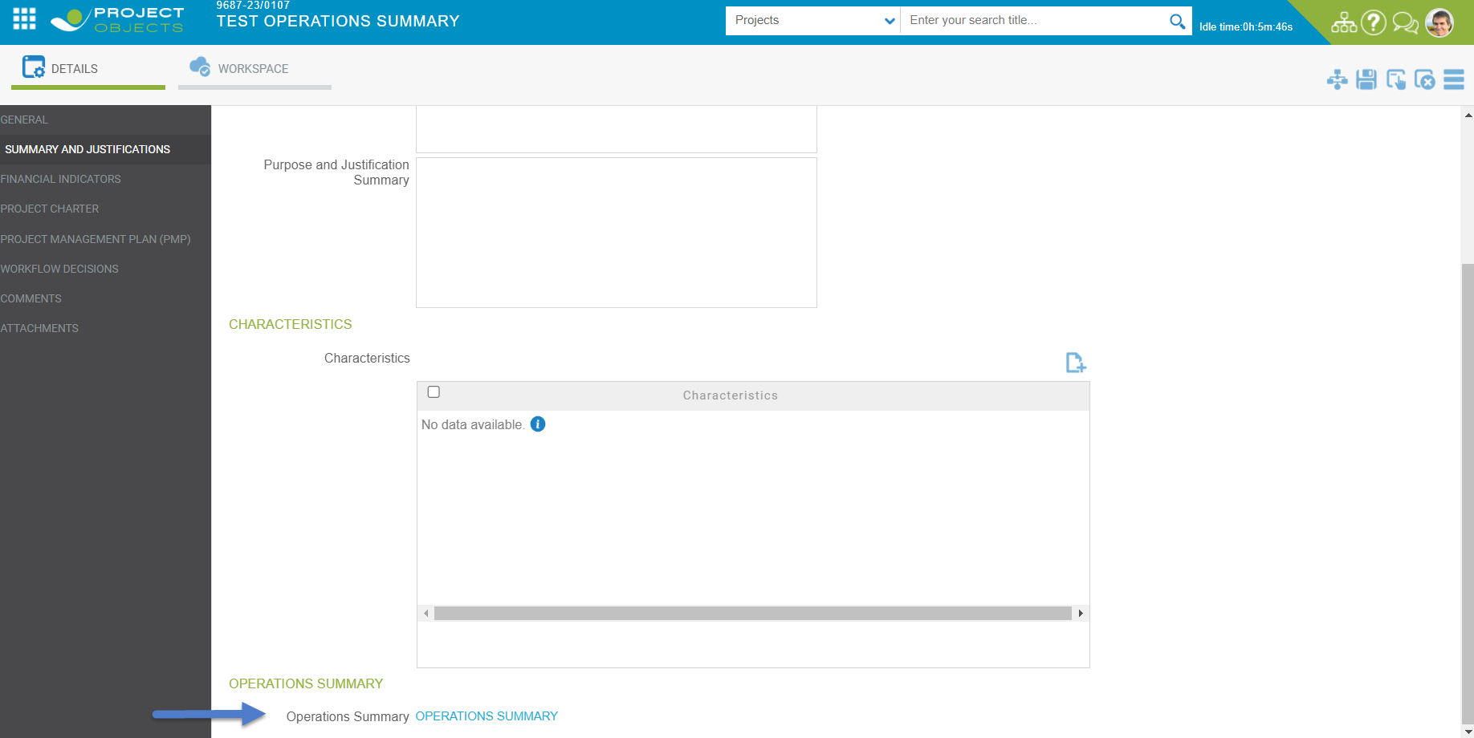

In this control we can add a message and can add attachments and when email will be fired, it will be containing the message and the latest attachment name that is attached in the control. (It can be changed by the user)  
  
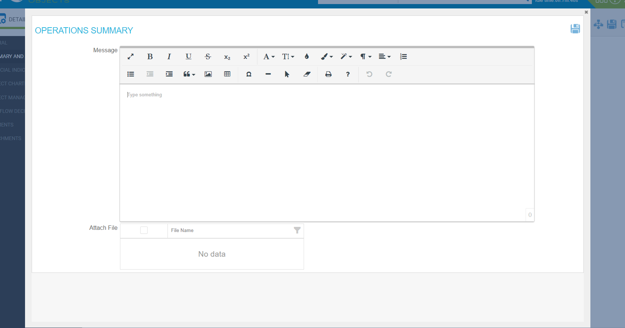

For the Attachments to be visible in the Operations Summary Control we need to add **Approval Documents** in the Attachment Control ->  
  
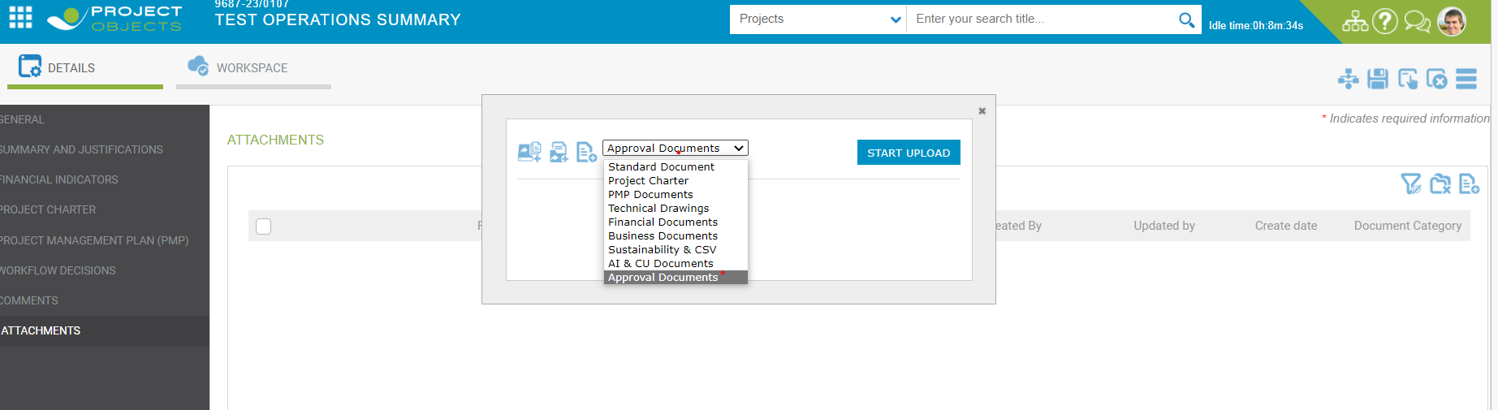  
  
Two documents attached -> Latest attached – Document.docx   
  
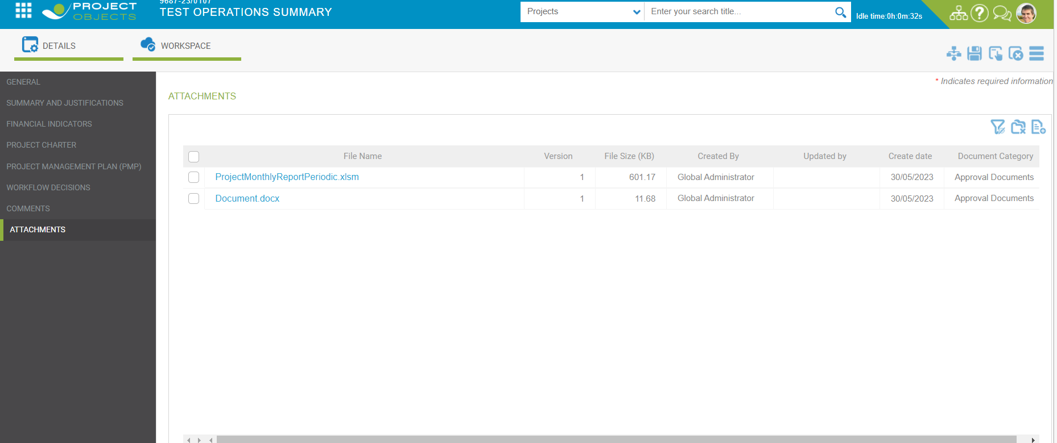  
  
Message can be written in the control and the latest attachment name comes as selected and can be changed and saved.

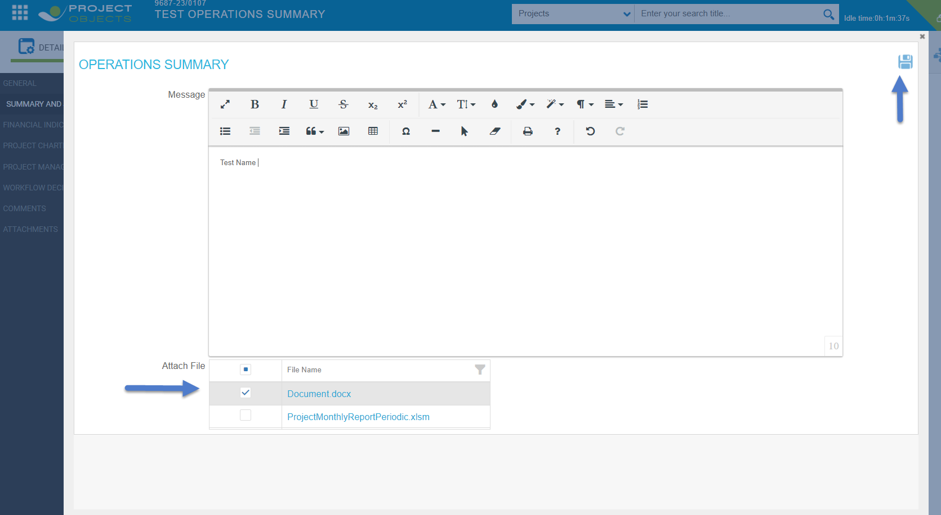

When One Pager will be enabled at any step , Operations Summary Control will be also visible there   
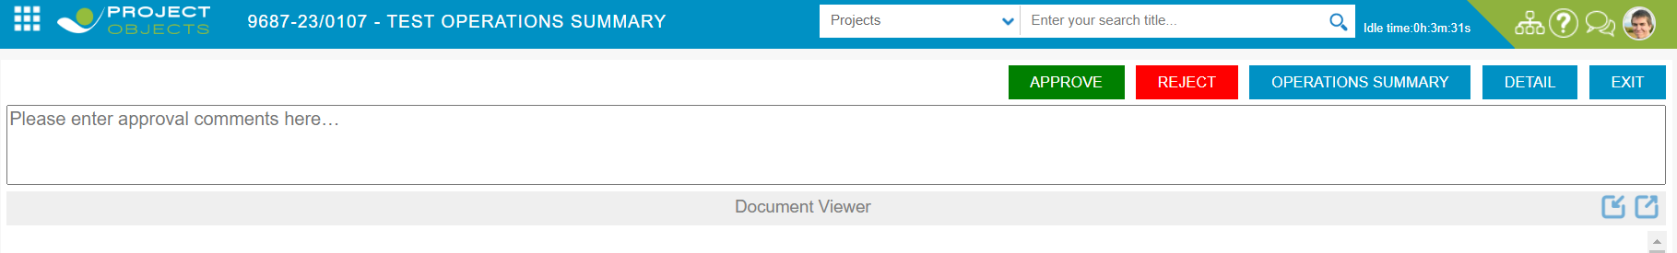  
  
Same control will be visible there ->  
  
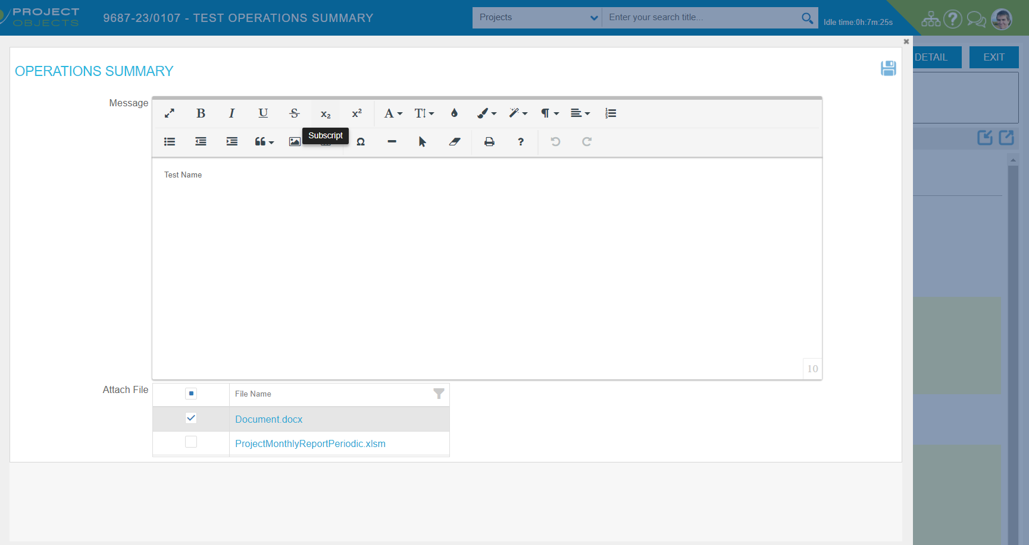  
  
For the control to be editable , we need to make the following permission of **“Management Comment”** **ON** ->  
  
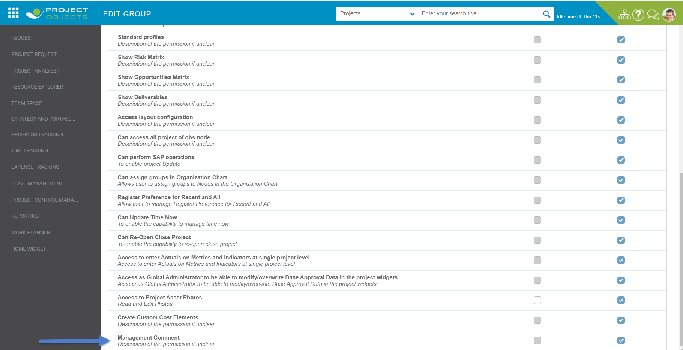

If the permission of **“Management Comment”** if **OFF** then ->  
  
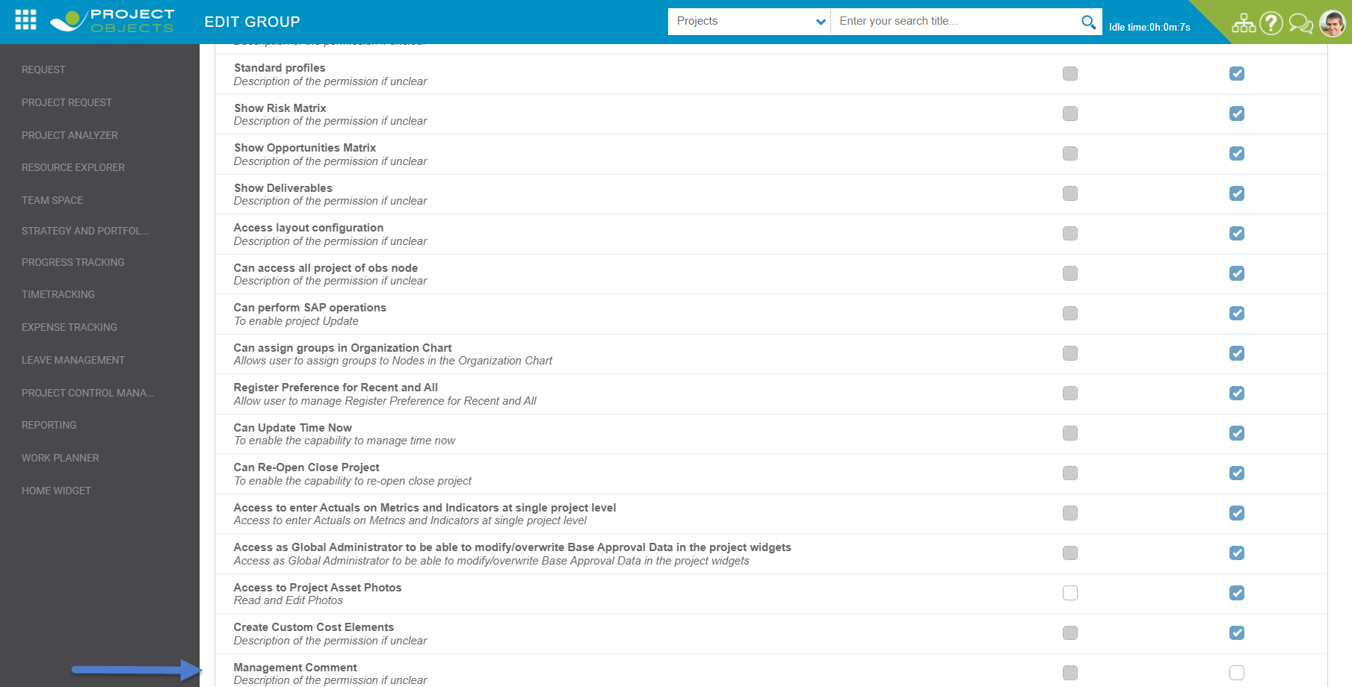  
  
The control will come as disabled now ->  
  
Details Page->

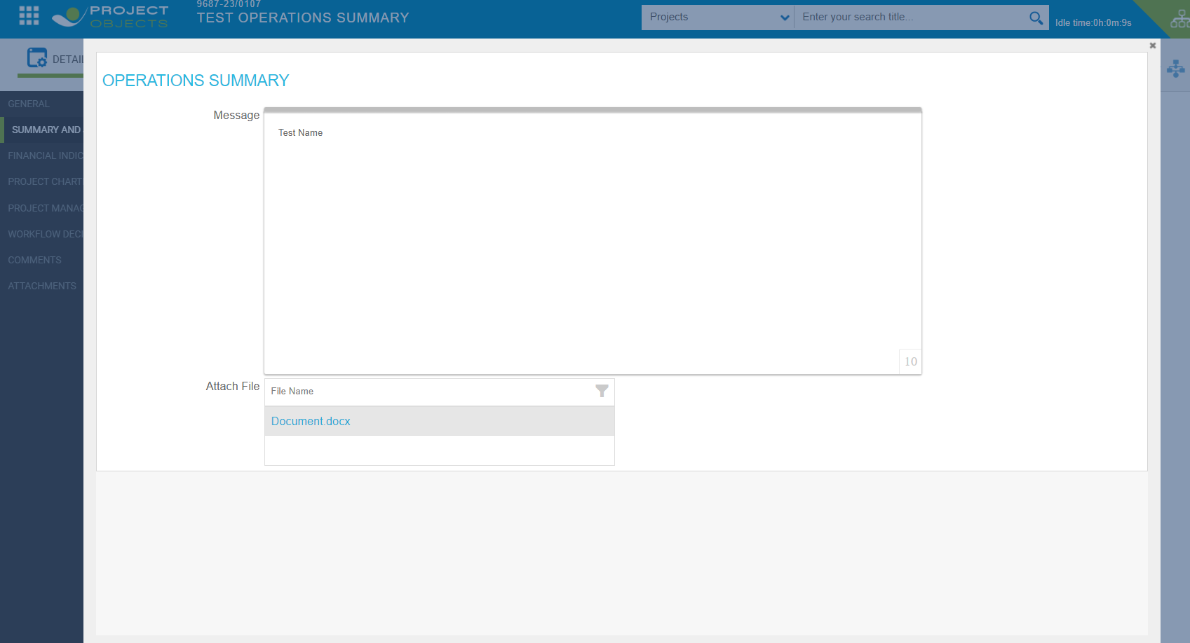

Operation’s Summary control on One Pager also comes as disabled ->  
  
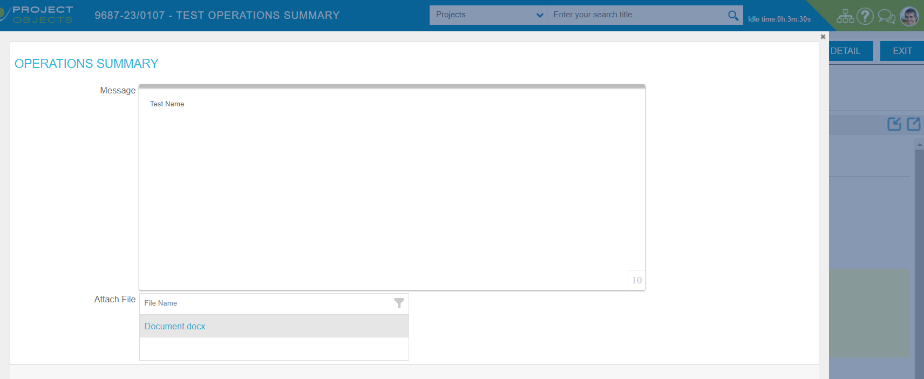

Management Comment permission is activated for the next User Groups: Global Administrator, Zone/GMB Chief Engineer, Zone/GMB EVP. For those user groups it will be editable, for other user groups this control is availbale as read only only at workflow step where it is visible.

Management comment is also implemented to be used in Email notifications templates:

3. Credit Submission form changes

Two dropdown were added to the Tab “Workflow Decisions”:

1. Credit Type
2. BoD Required

Both of those dropdowns are used in SFW workflow conditions.

BoD Requered dropdown is setup as a mandatory field. The issue is that the mandatory fields are not taken into account in 1-pager. This needs to be implemented as this field should be completed by Global Admin in the workflow step where 1-pager is activated.

Also a new Section “Operation Summary” and the SysControl Management comment (label “Operations Summary” are available under the Tab “Summary and Justification”:

I do not see this Section in the form designer. Is it coming from the backend and setup in the Management comment functionality?

1. **User Groups schanges**

Two new User Groups were created to be used in the SFW workflow:

GR33 – Zone/GMB EVP (PreProd). For Production we will use the User Group GR31 Responsible EVP for this workflow step insteed. Confirfirmed by Norman and Dana 09/06/2023. GR33 is not requered.

CU06 – COMES

1. **Workflow changes**

A new workflow was implemented for the SFW process, now only for the Zone approval type.

The last and current workflow version on PreProd is CRWF31 – Zones SFW_V6.

1. **Additional review functionalitie changes**
   1. The Sequencional additional review process was implemented. Review initiator can select now to which reviewer a notification email will be sent. Reviewers, who are not selected for email notification will receive onle review action:

5.2 Text of email notification for additional reviewers is changed:

5.3.Icons for the additional revie process are changed

Add reviewers:

Reviwer comments:

5.4. The dropdown “Recommendation” of the pop-up “Add Reviews” is changed, only two options are left:

5.5. Notification once reviewiver completed a review.

Email notification are getting sent now not only to the Review Initiator but to all the Step Owners of the step whre review is initiated.

1. **New Advance options in the workflow configuration**

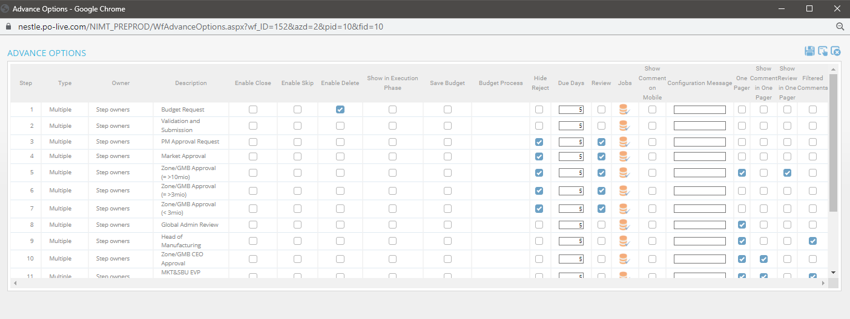

6.1.Show comment in one pager – only workflow comments of the selected steps will be shown on 1-pager.

6.2. Show Review in OnePager - only additional review comments of the selected steps will be shown on 1-pager.

6.3. “Filtered Comments” – this option allow to show “filtered list” or “full list” of additional review comments in 1-pager.

A new function “Can select EB Approval Comments” is now availble in the project Details, Tab “Additional Reviwer”. This option allows to user with a specific permission select commets of additional reviwers which will be represented in 1-pager:

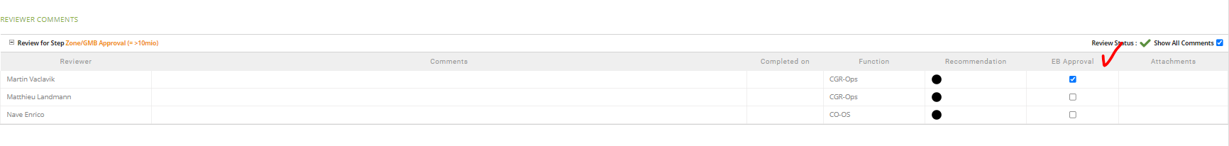

This filter will be applied only on steps where the advance option “Filtered Comments” is activated.

The User Group permission “Can select EB Approval Comments”. Now this permission is activated only for Global Admin User Group:



For all the other groups the check box is not availble in the column EB Approval:

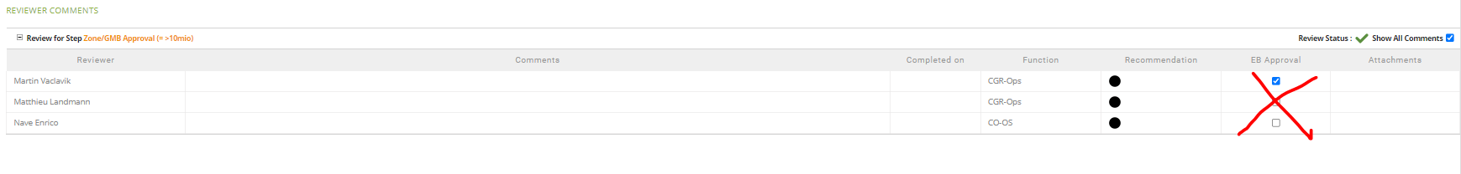

1. **1-Pager functionality changes**

7.1.Desighn of 1-Pager tab was changed, including icons, fields order and sizes, names of the fields in the workflow and additional review comments sections.

7.2.Once a user clicks “Approve” or “Reject” the specific massage is implemented for a release action. After credit is “Approved” or “Rejected” from 1-pager and specific message is represented for a user the view moves from 1-pager to the HomePage.

7.5. It is possible to release credit from 1-pager if the iinitiated review process has not been completed yet. In this case a user will reciewe an information messege on a top of his screen.

1. **Email notifications**

8.1.Management comment is availble as email notification. Please find above



8.2.Number of additional Email Notifications templates are implemented for the SFW workflow: CR03 and CR04



8.3. For email notification teplate configuration next chages wered done:

- SBU is available (was not appeaing in the email notifications before)

- Facility code was removed from [Fasility], only facility name is left.